CHAPTER 9: Sedimentary, igneous and metamorphic rocks
Worksheet 9.2

Igneous rocks
Student: Class:

1. (a) The figure below left shows a region of past igneous activity. Igneous rocks are found in the two locations marked by arrows. Label these rocks as either intrusive igneous rocks or extrusive igneous rocks.
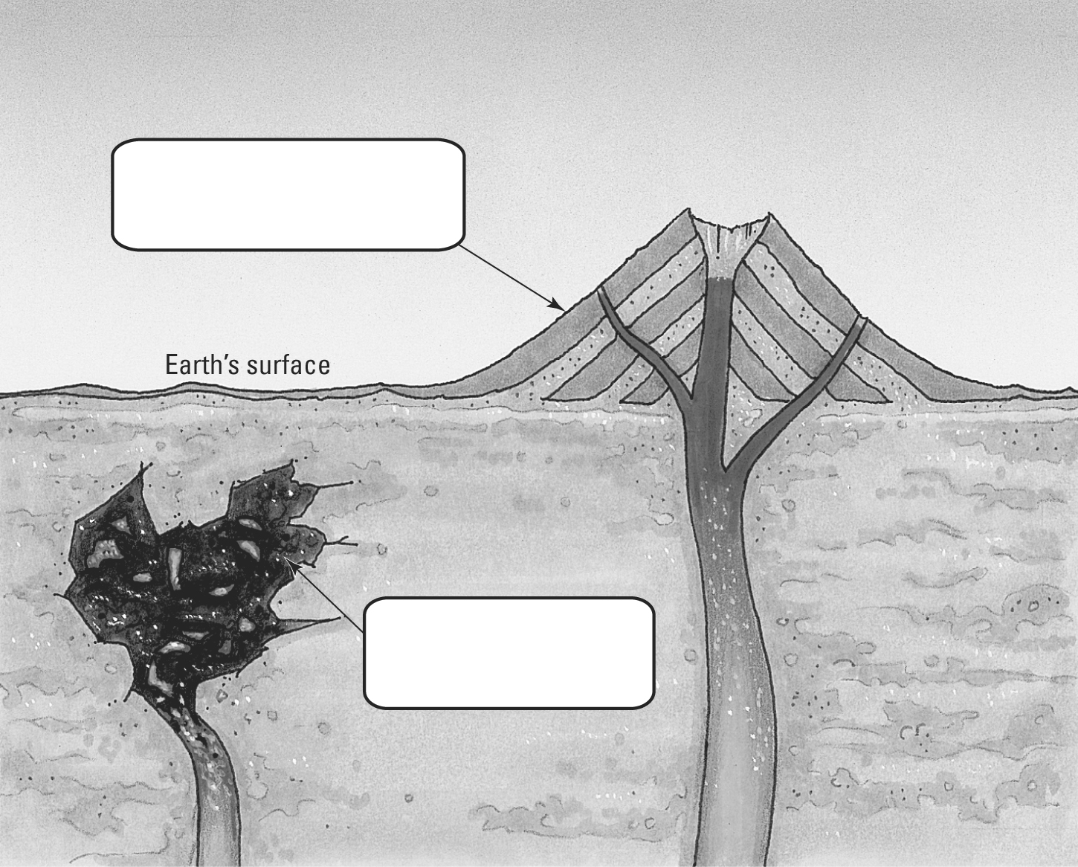 | (b) The photos below show sections of rocks taken from these sites. Section A is coarse grained, and section B is fine grained. Identify which rock is intrusive and which extrusive.
 | 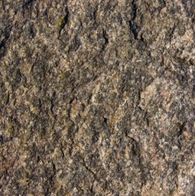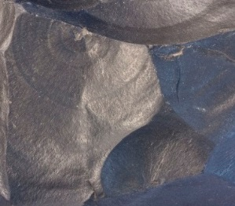
 | Section A Section B
2. Read the information about various igneous rocks and create a written classification key to distinguish them.
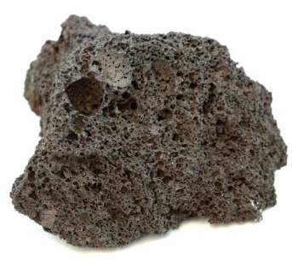 | 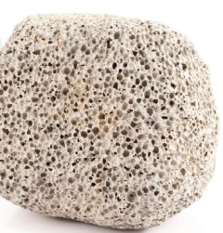 | 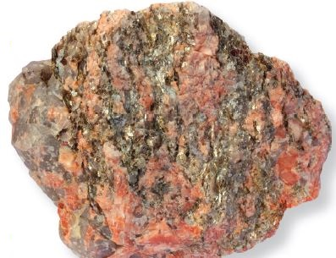
Scoria | Pumice | Granite
Pumice: pale coloured rock; very light; very porous; many small gas holes
Scoria: red-brown or grey rock; light but heavier than pumice; porous; small and large holes
Obsidian: smooth, glassy black rock; non-crystalline
Granite: hard; dense; large crystals; speckled colours (white, black, glassy, pink)
Basalt: grey or black rock; very fine crystals; hard; dense
Key:
1A.
1B.
Section A photo: Victor Azovkin / 123RF.com
Section B photo: Siim Sepp / 123RF.com
Scoria photo: Tyler Boyes / Shutterstock.com
Pumice photo: Rob Kemp / Shutterstock.com
Granite photo: Siim Sepp / Shutterstock.com

